# **Question 1:**

mkdir Subject

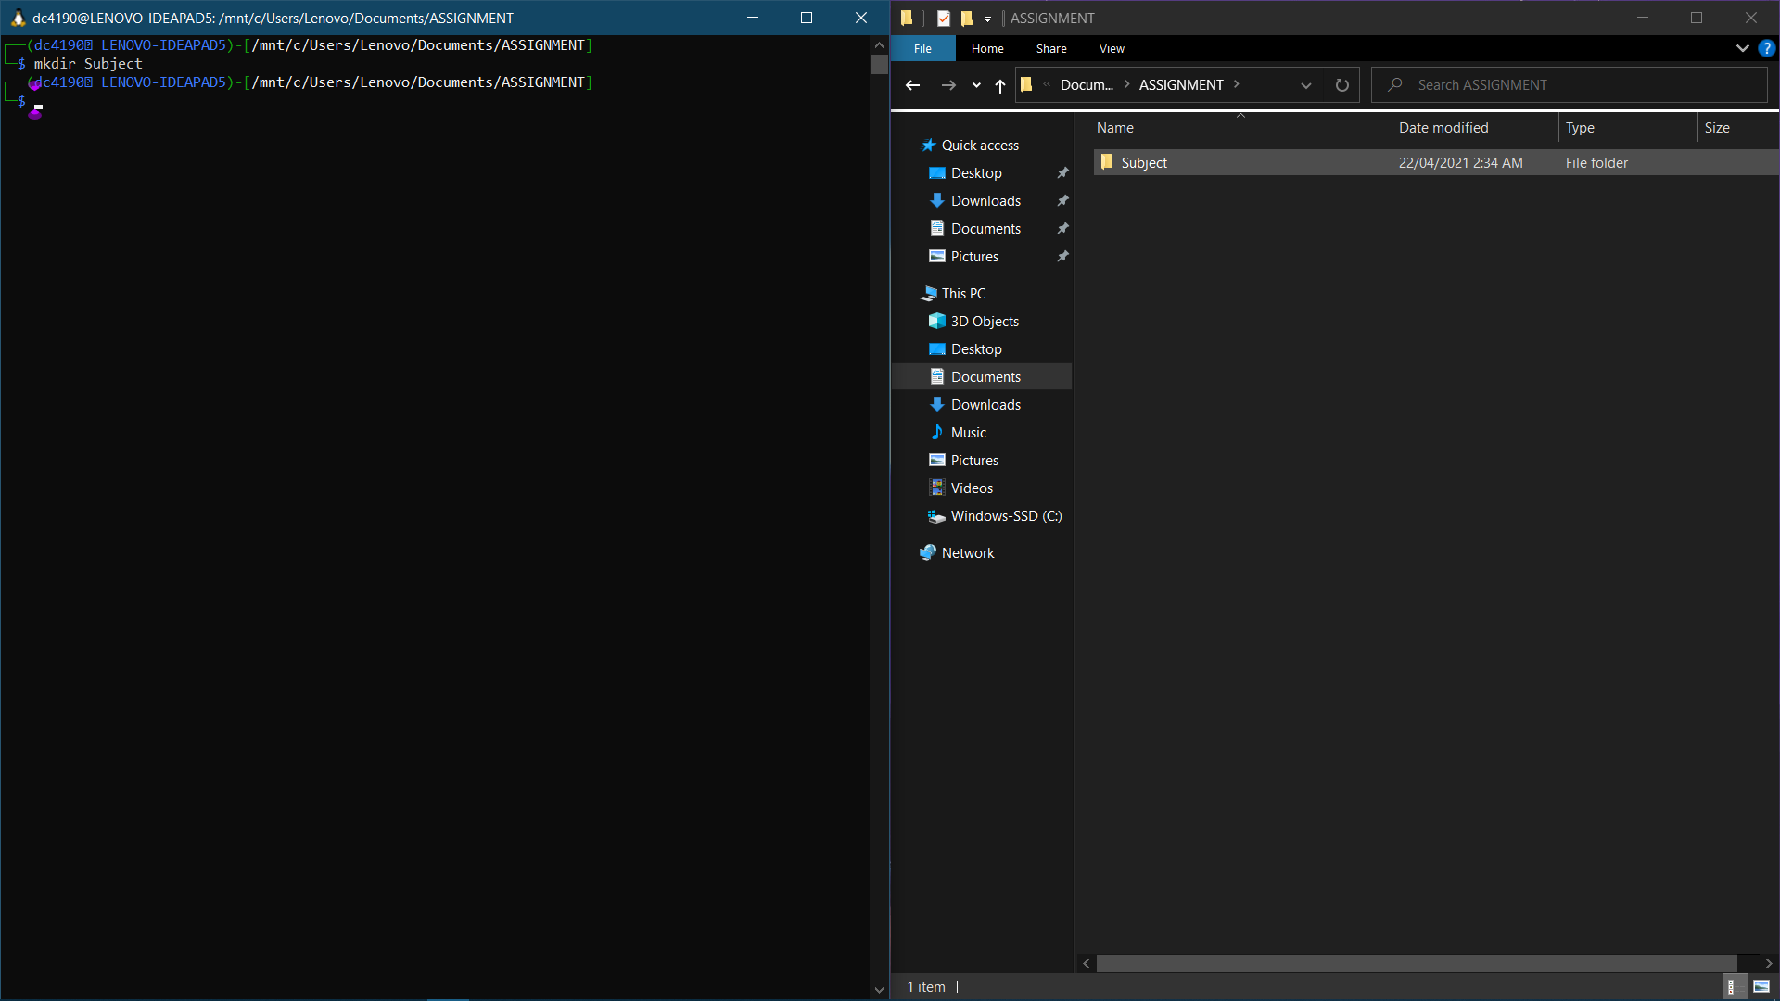

cd Subject

mkdir Physics Chemistry Mathematics CST

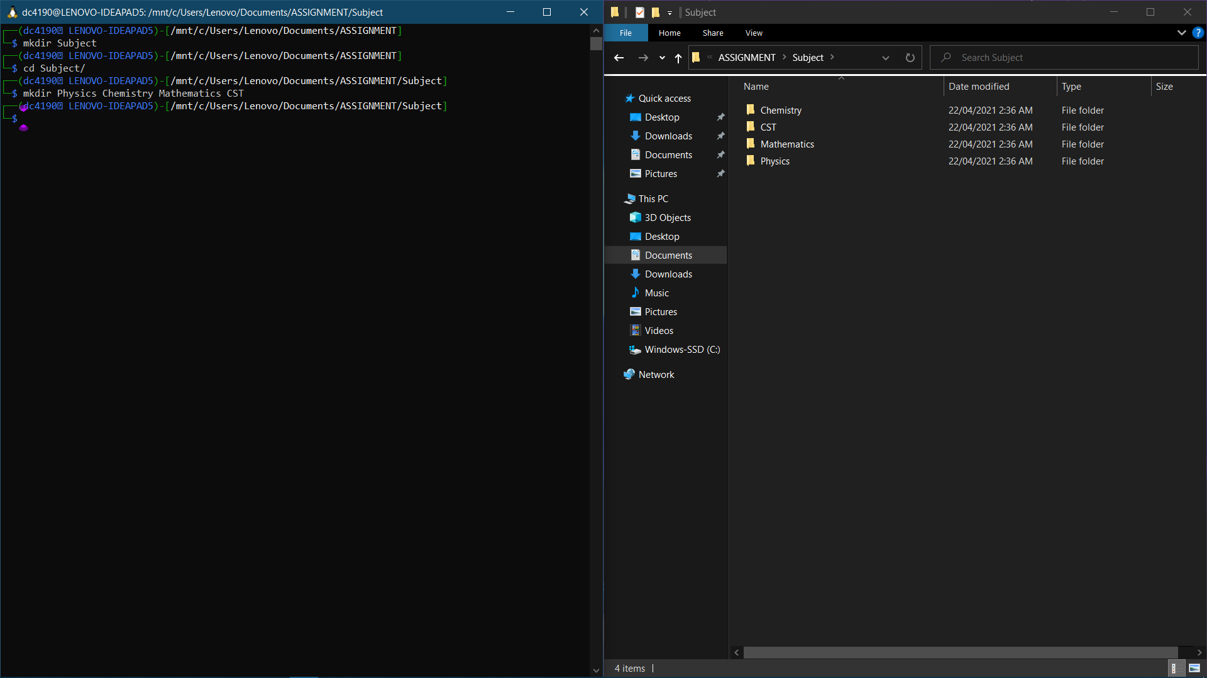

cd CST

mkdir DS OS DBMS

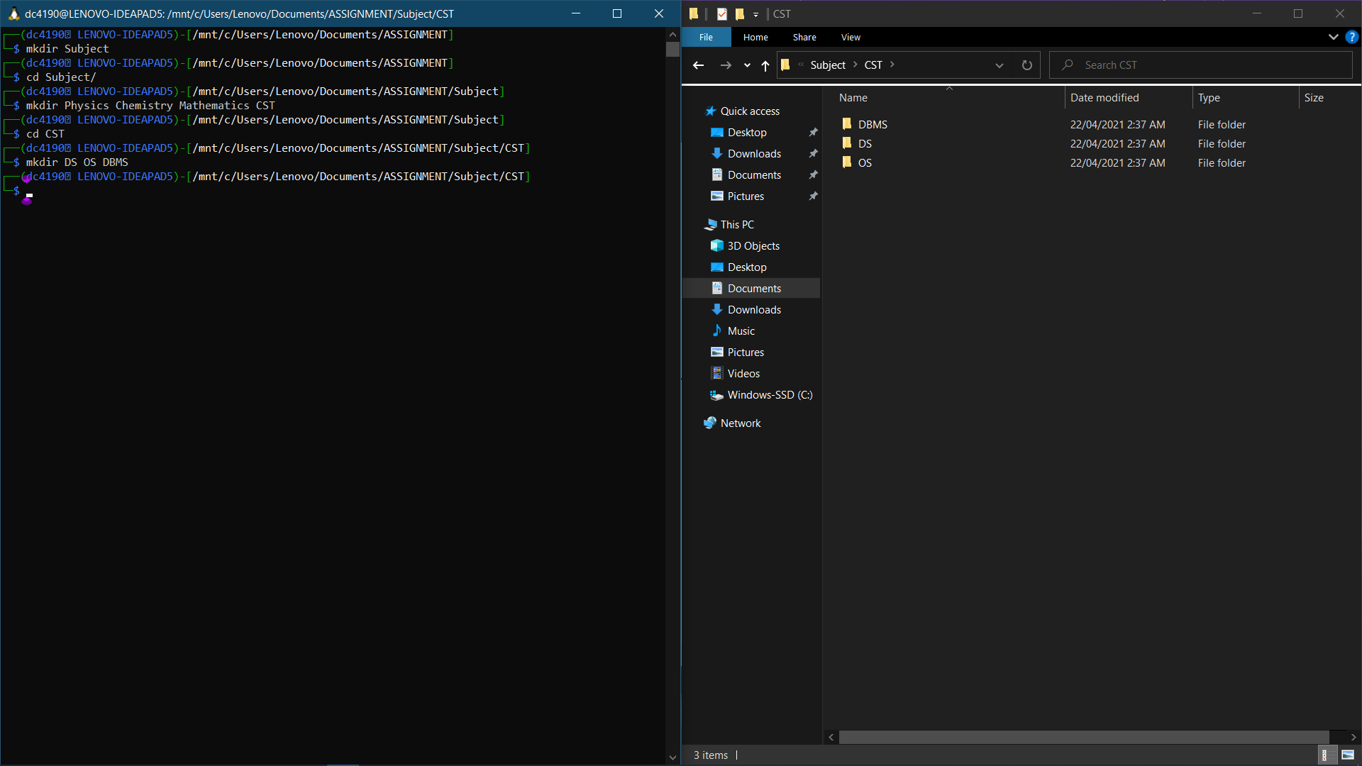

cd OS

nano Scheduling_algo

(Enter text) {Press Ctrl+X then Y then Enter]

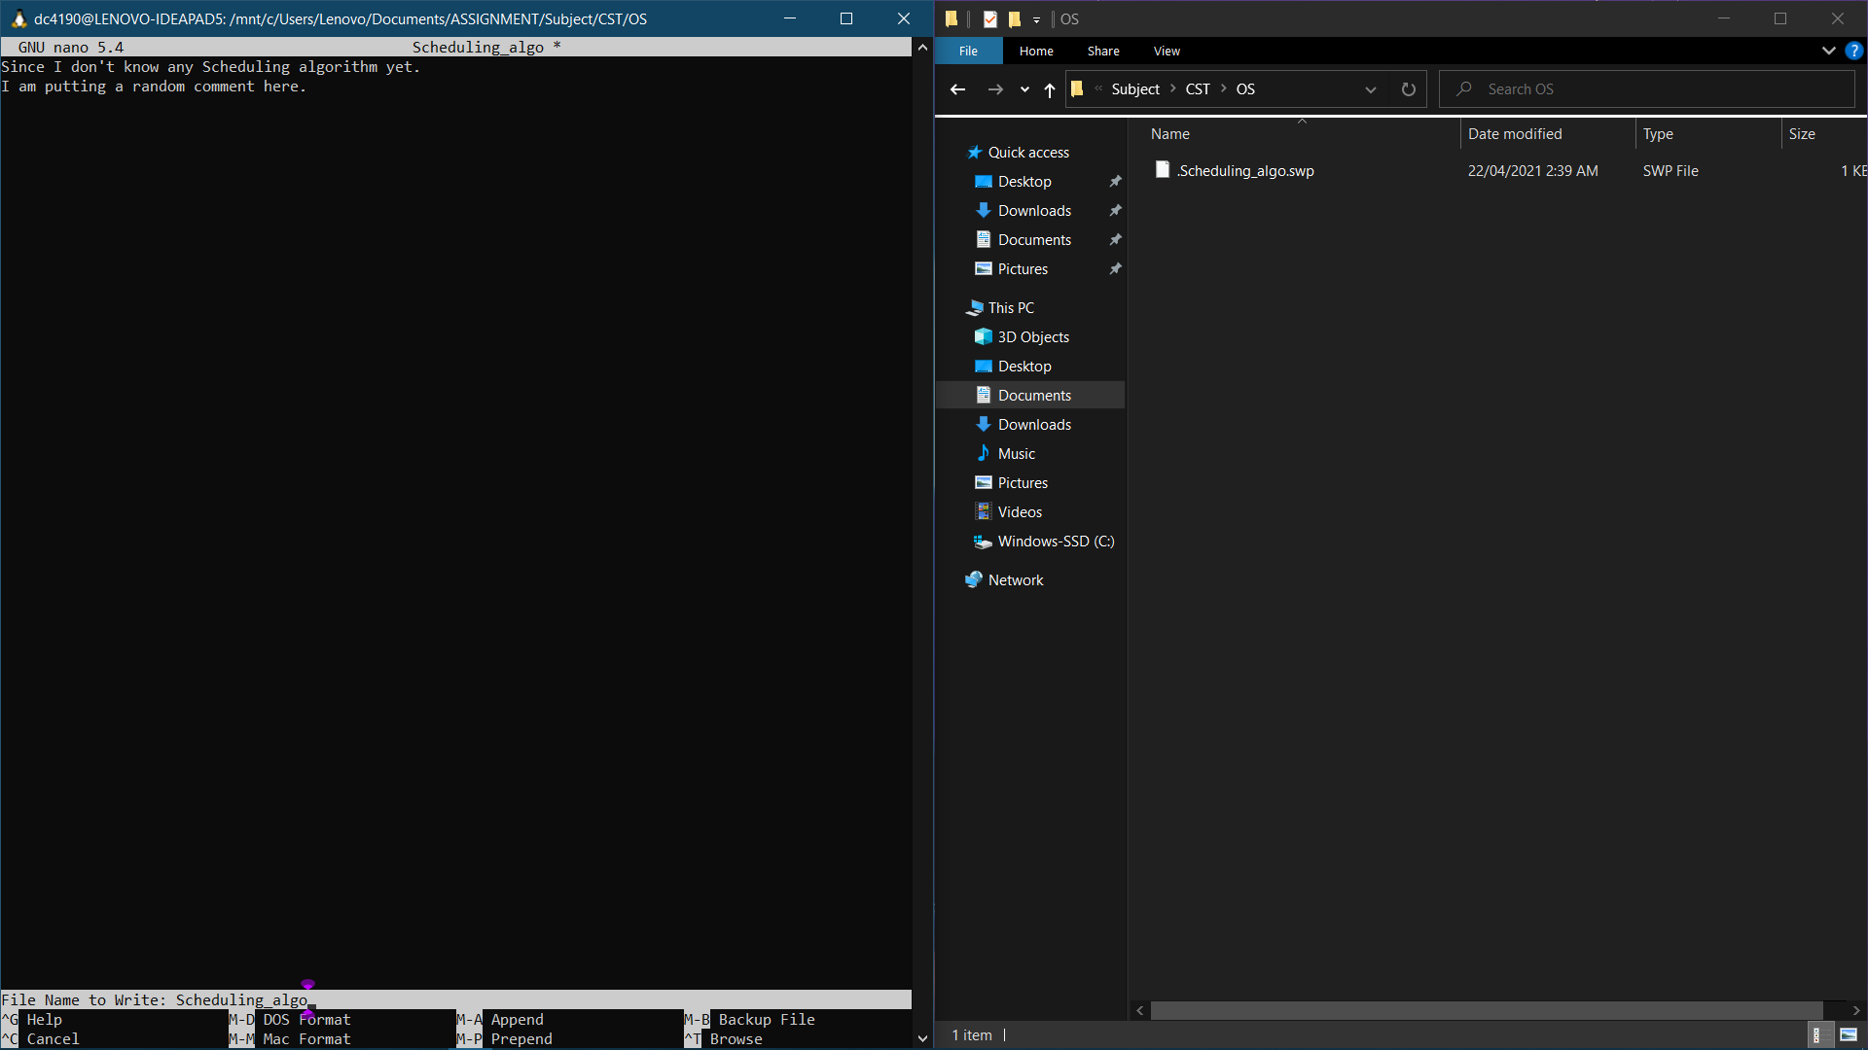

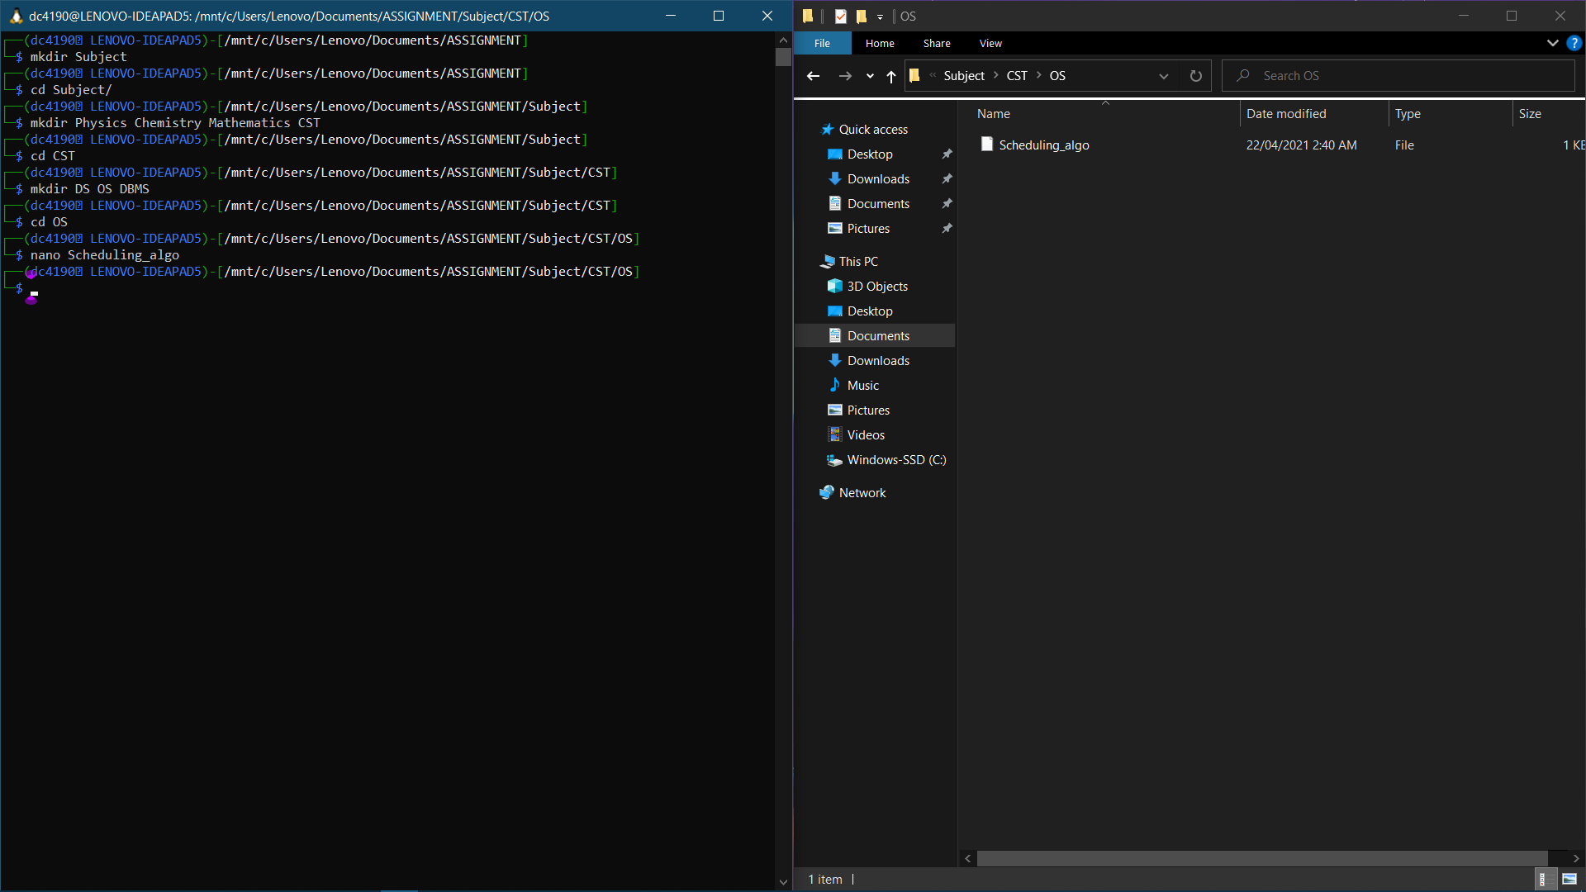

cd ..

cd ..

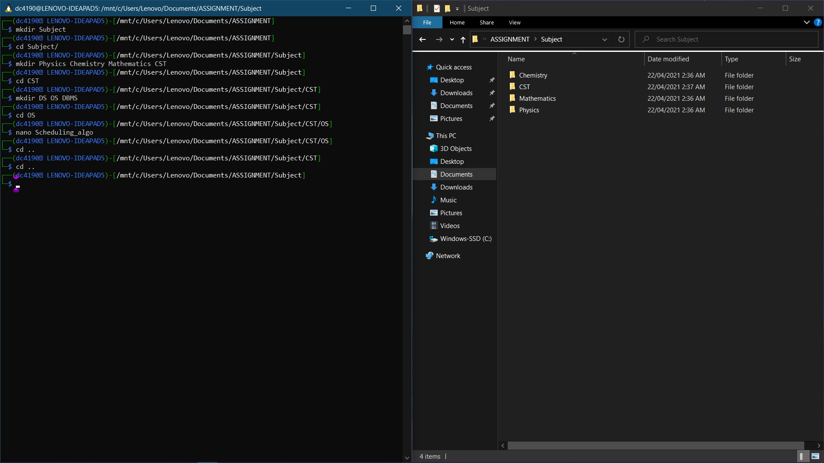

cd Physics

nano Thermodynamics

(Enter text) {Press Ctrl+X then Y then Enter}

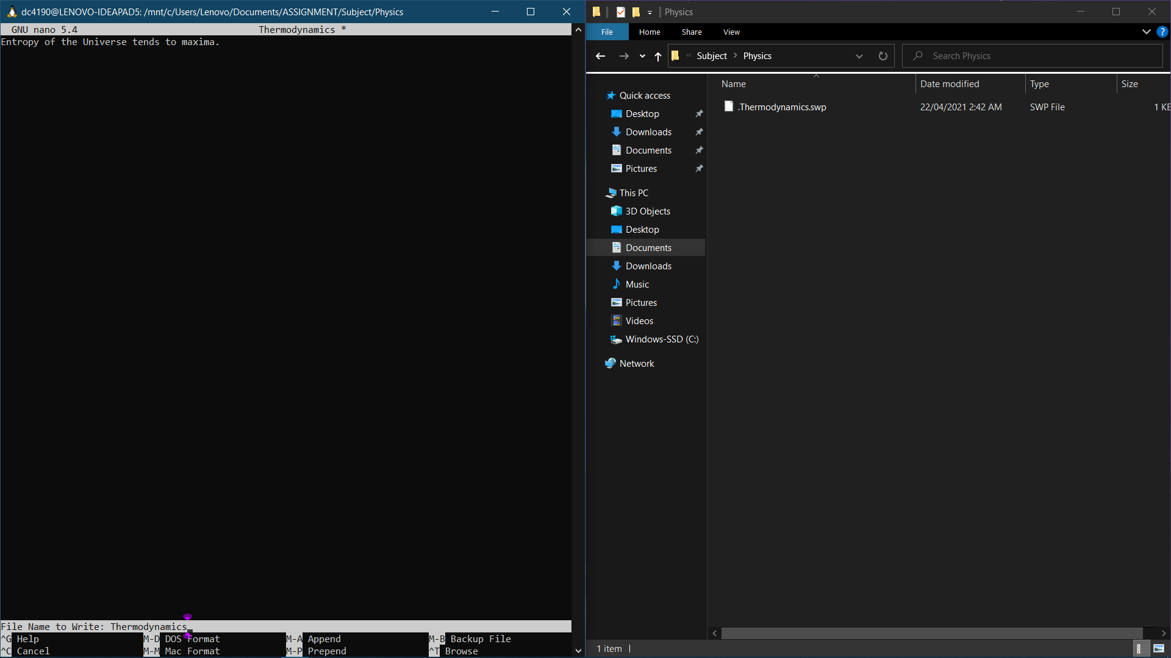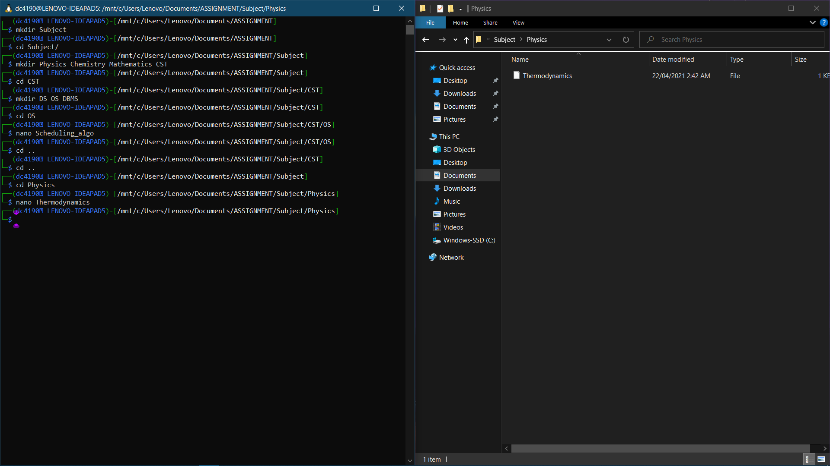

cd ..

cd Chemistry

nano Organic

(Enter text) {Press Ctrl+X then Y then Enter]

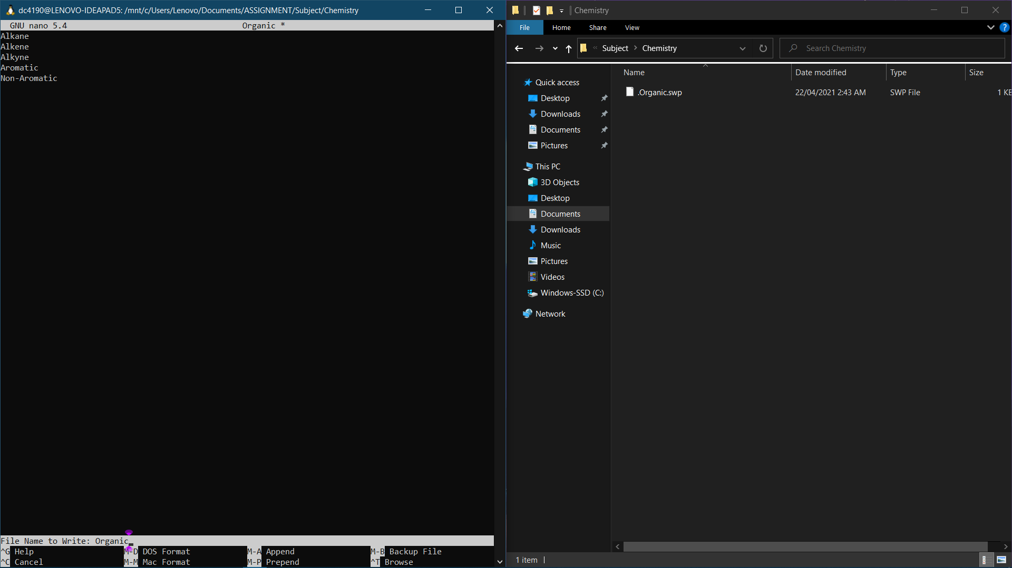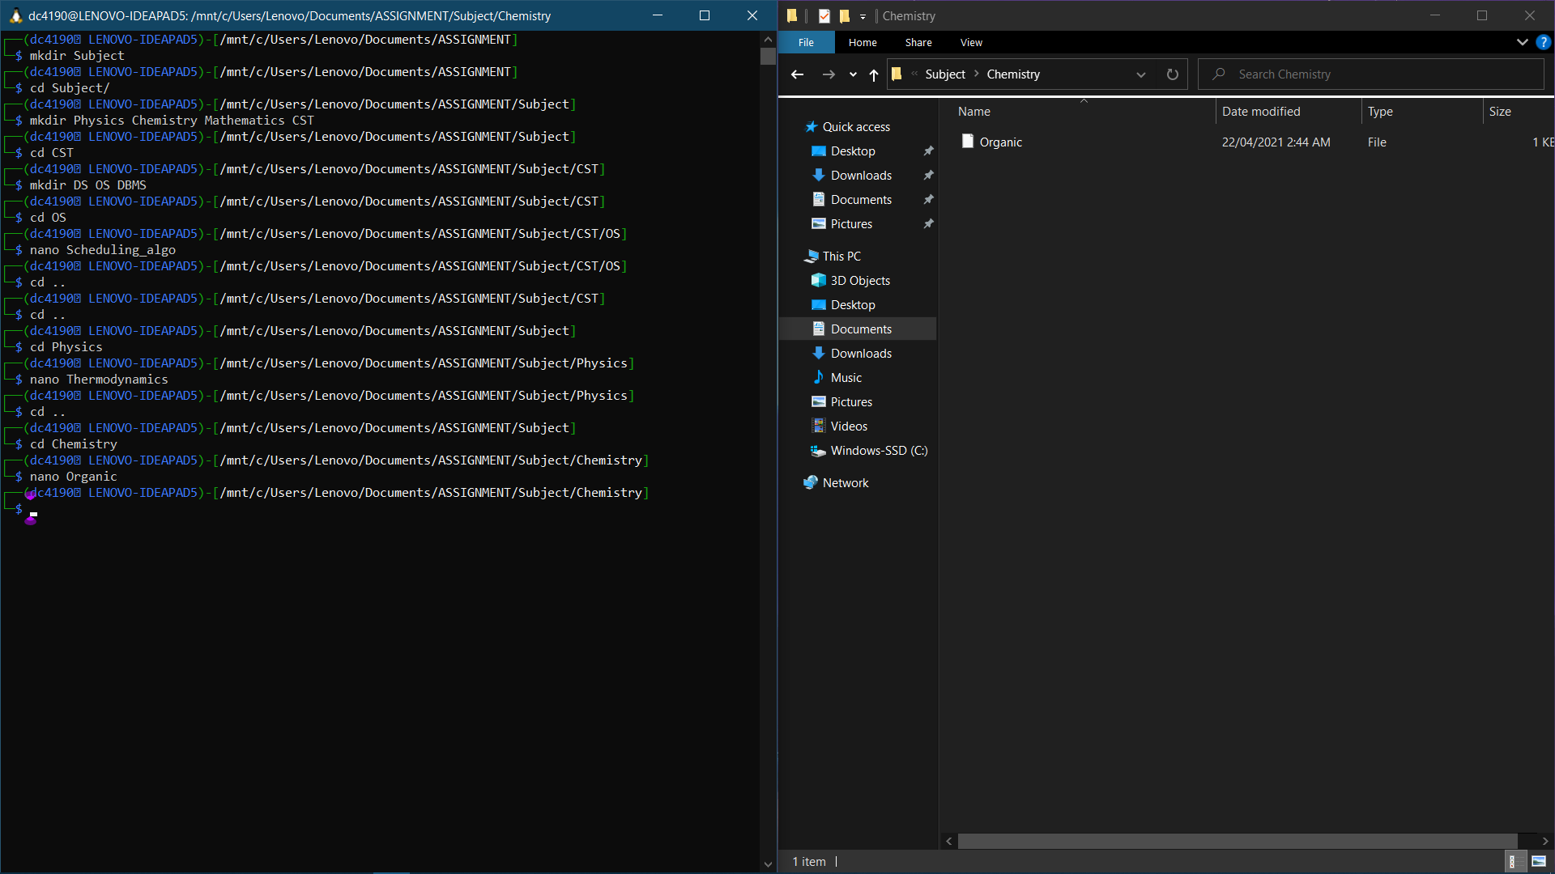

# **Question 2:**

a) touch empty1 empty2 empty3 empty4 empty5

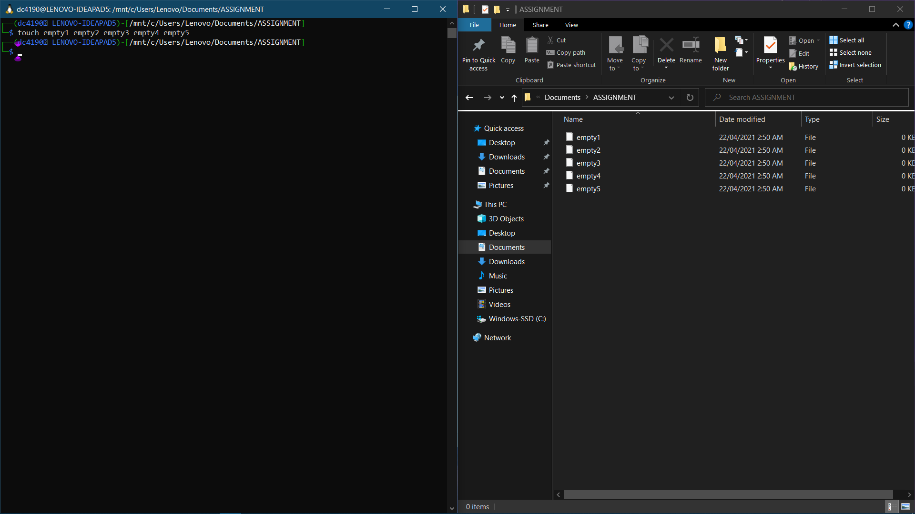

b) nano text

(Enter the asked details) {Press Ctrl+X then Y then Enter}

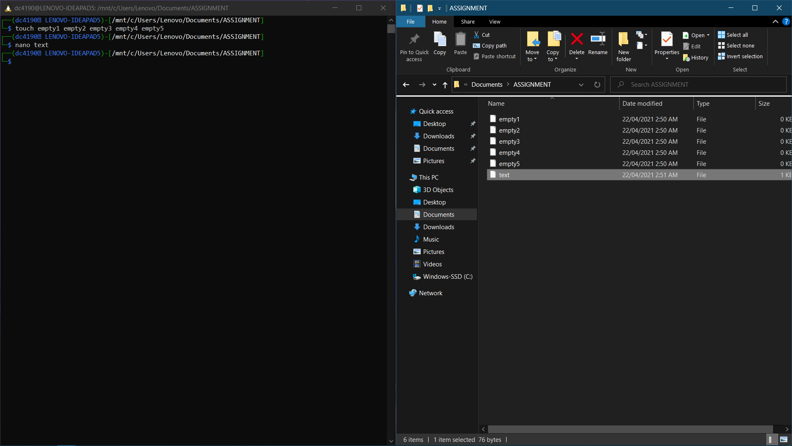

c) cat text

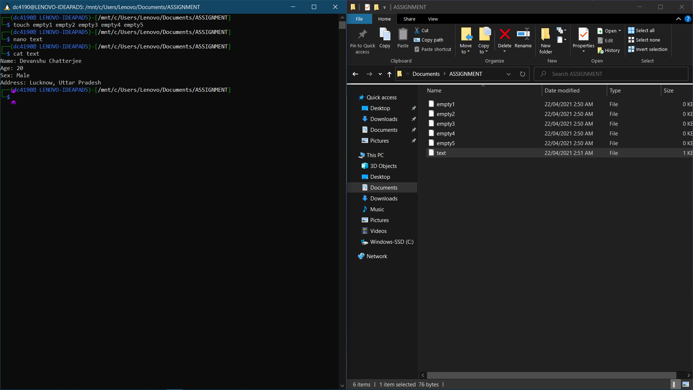

d) cp text new_text

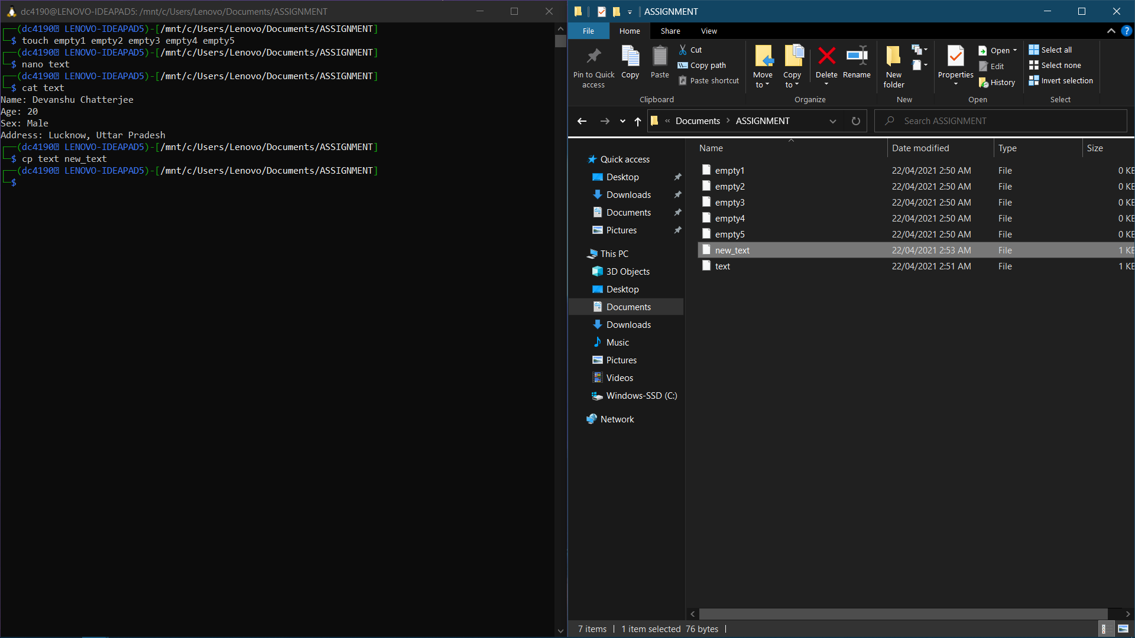

e) nano matter

(Enter text) {Press Ctrl+X then Y then Enter]

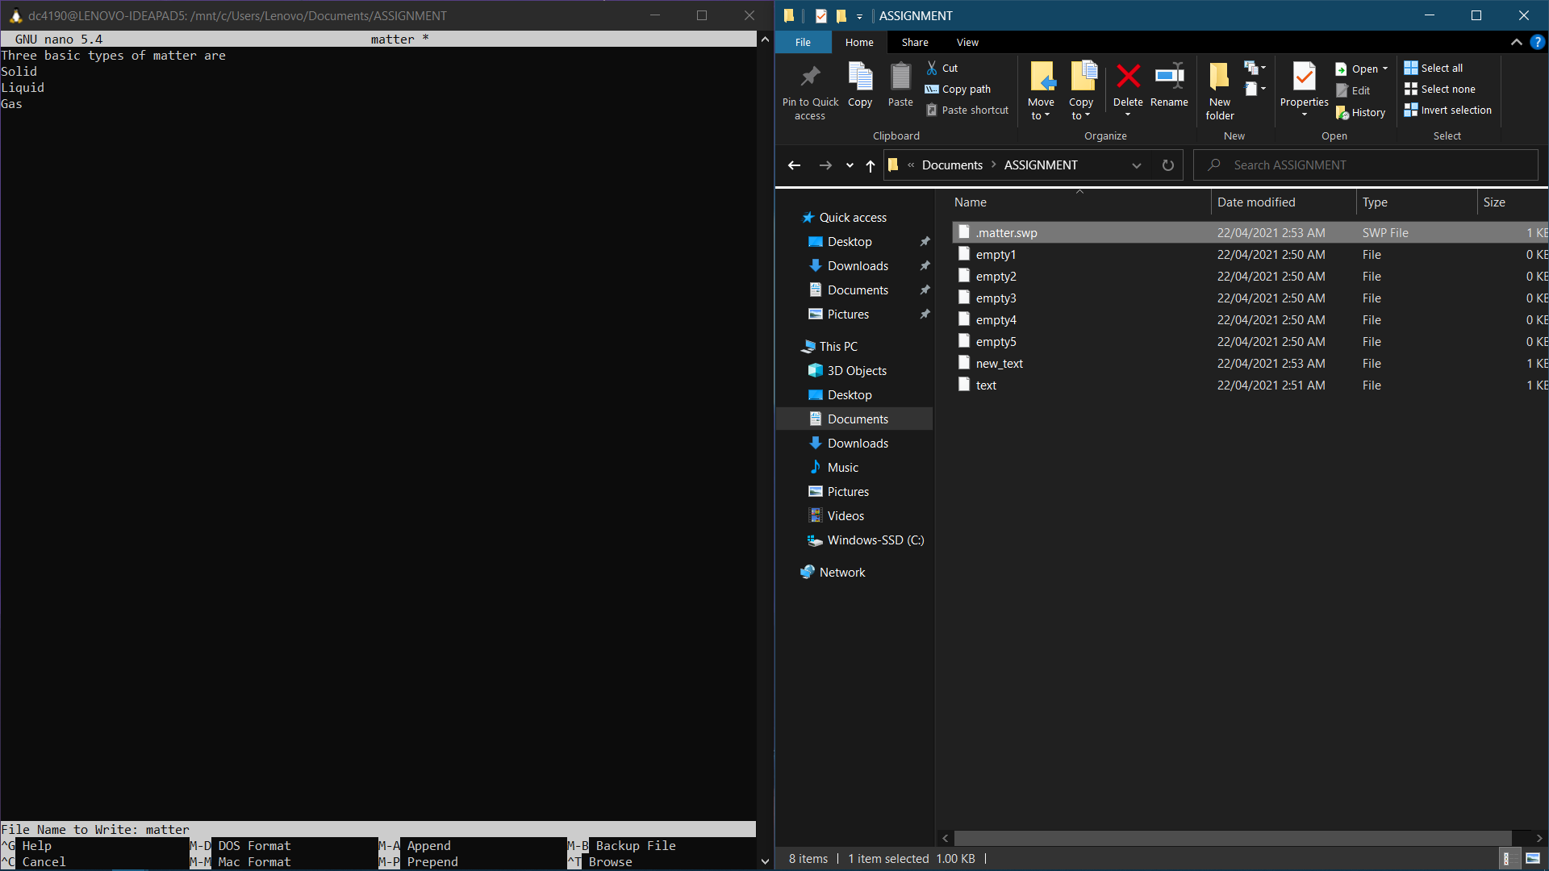

f) cat text matter > txt_mat

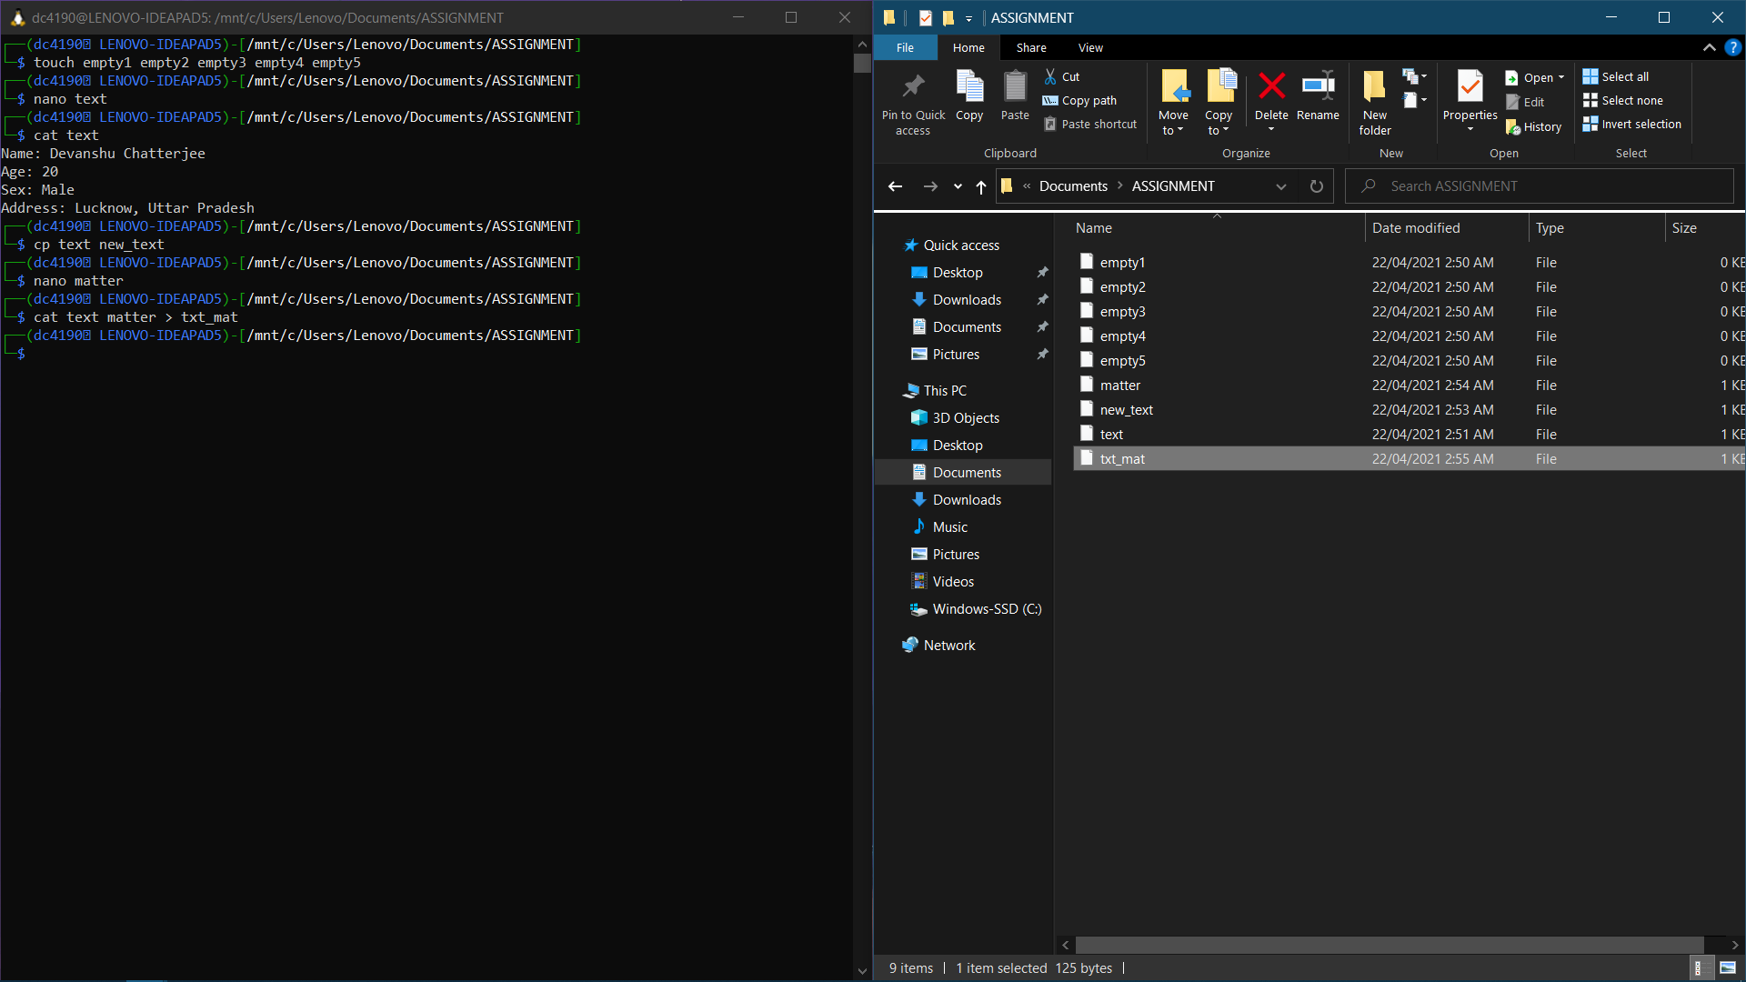

(Combined contents of text and matter files.)

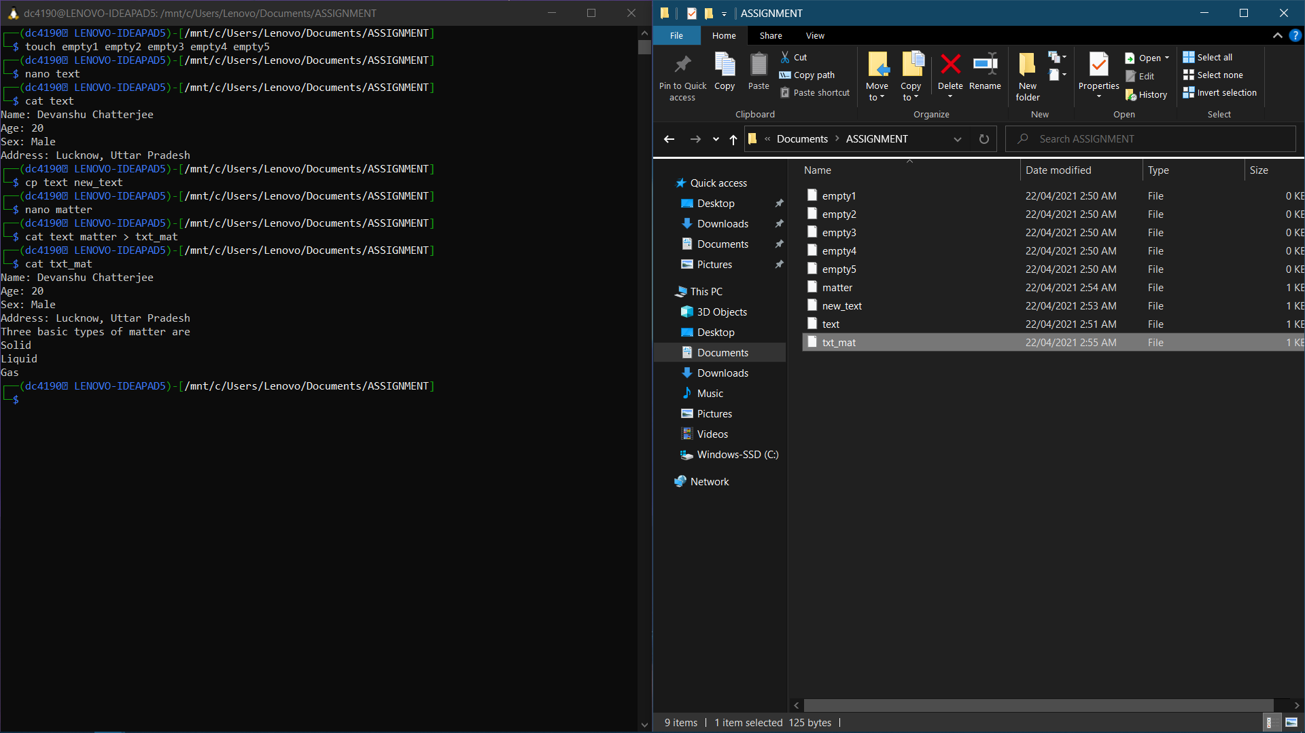

g) rm text

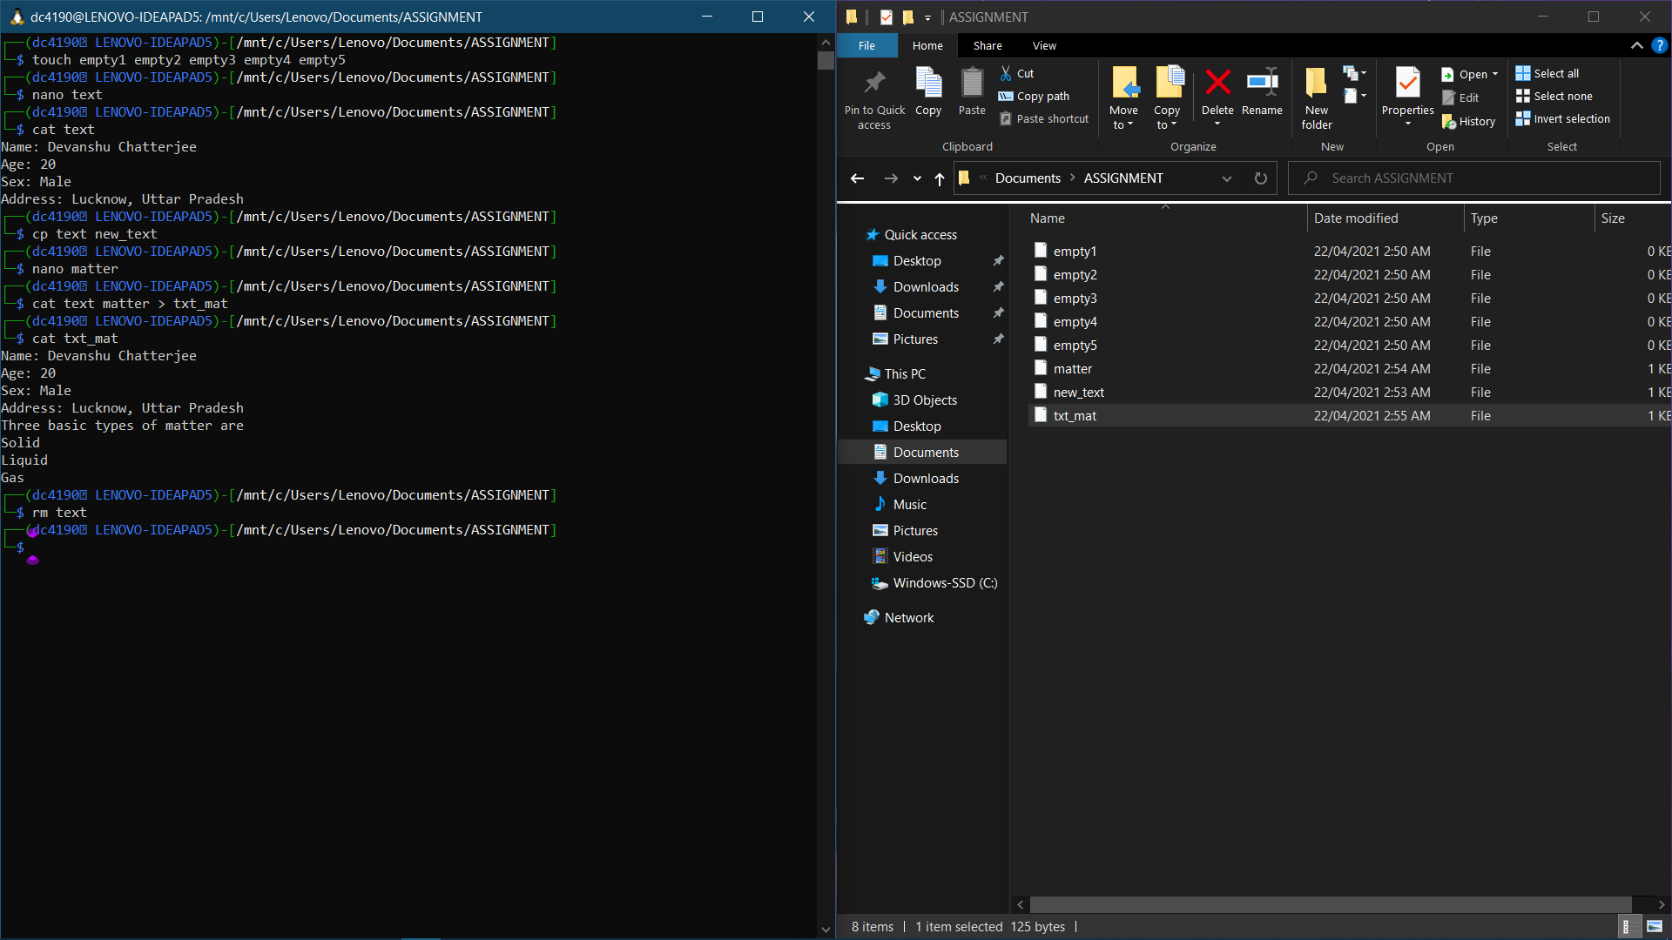

h) mv new_text old_text

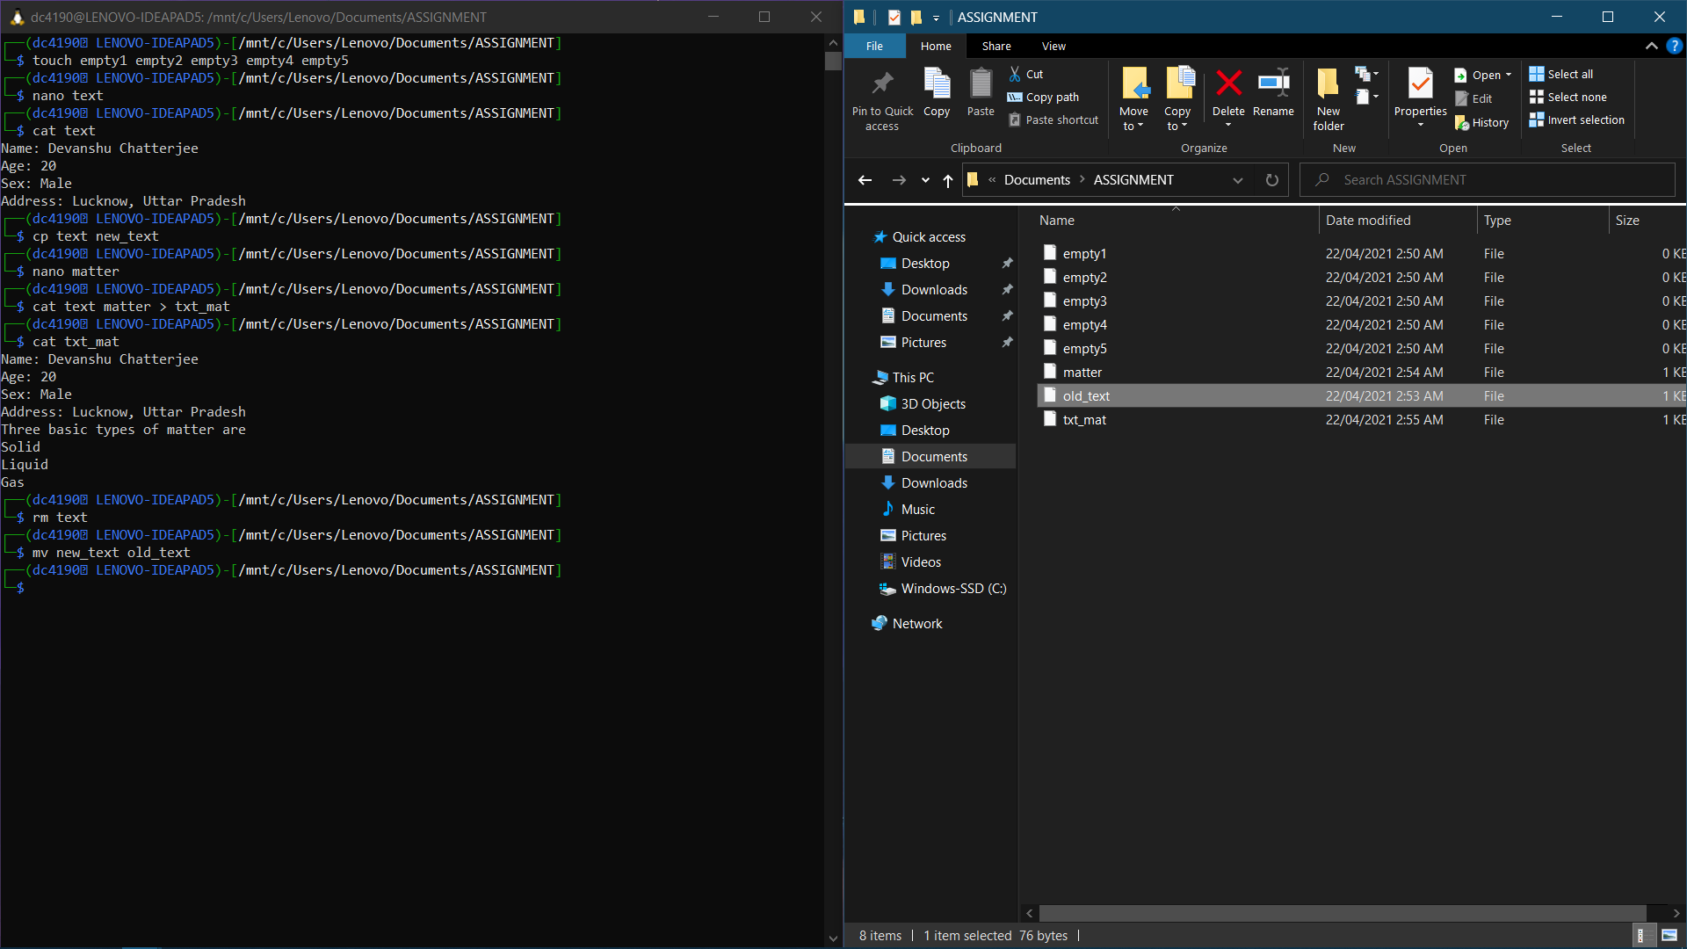

i) mkdir mydir

j) mv old_text mydir && mv matter mydir

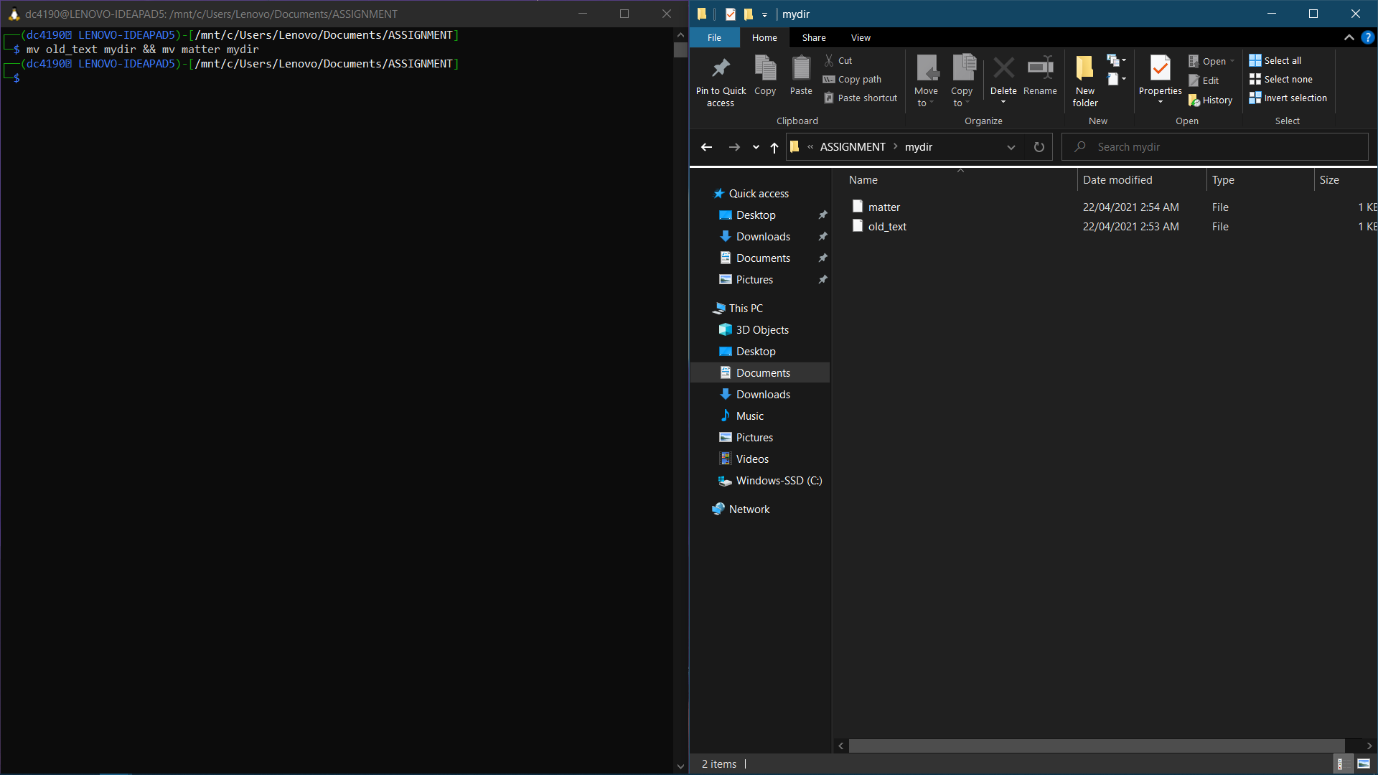

k) rm -rf empty*

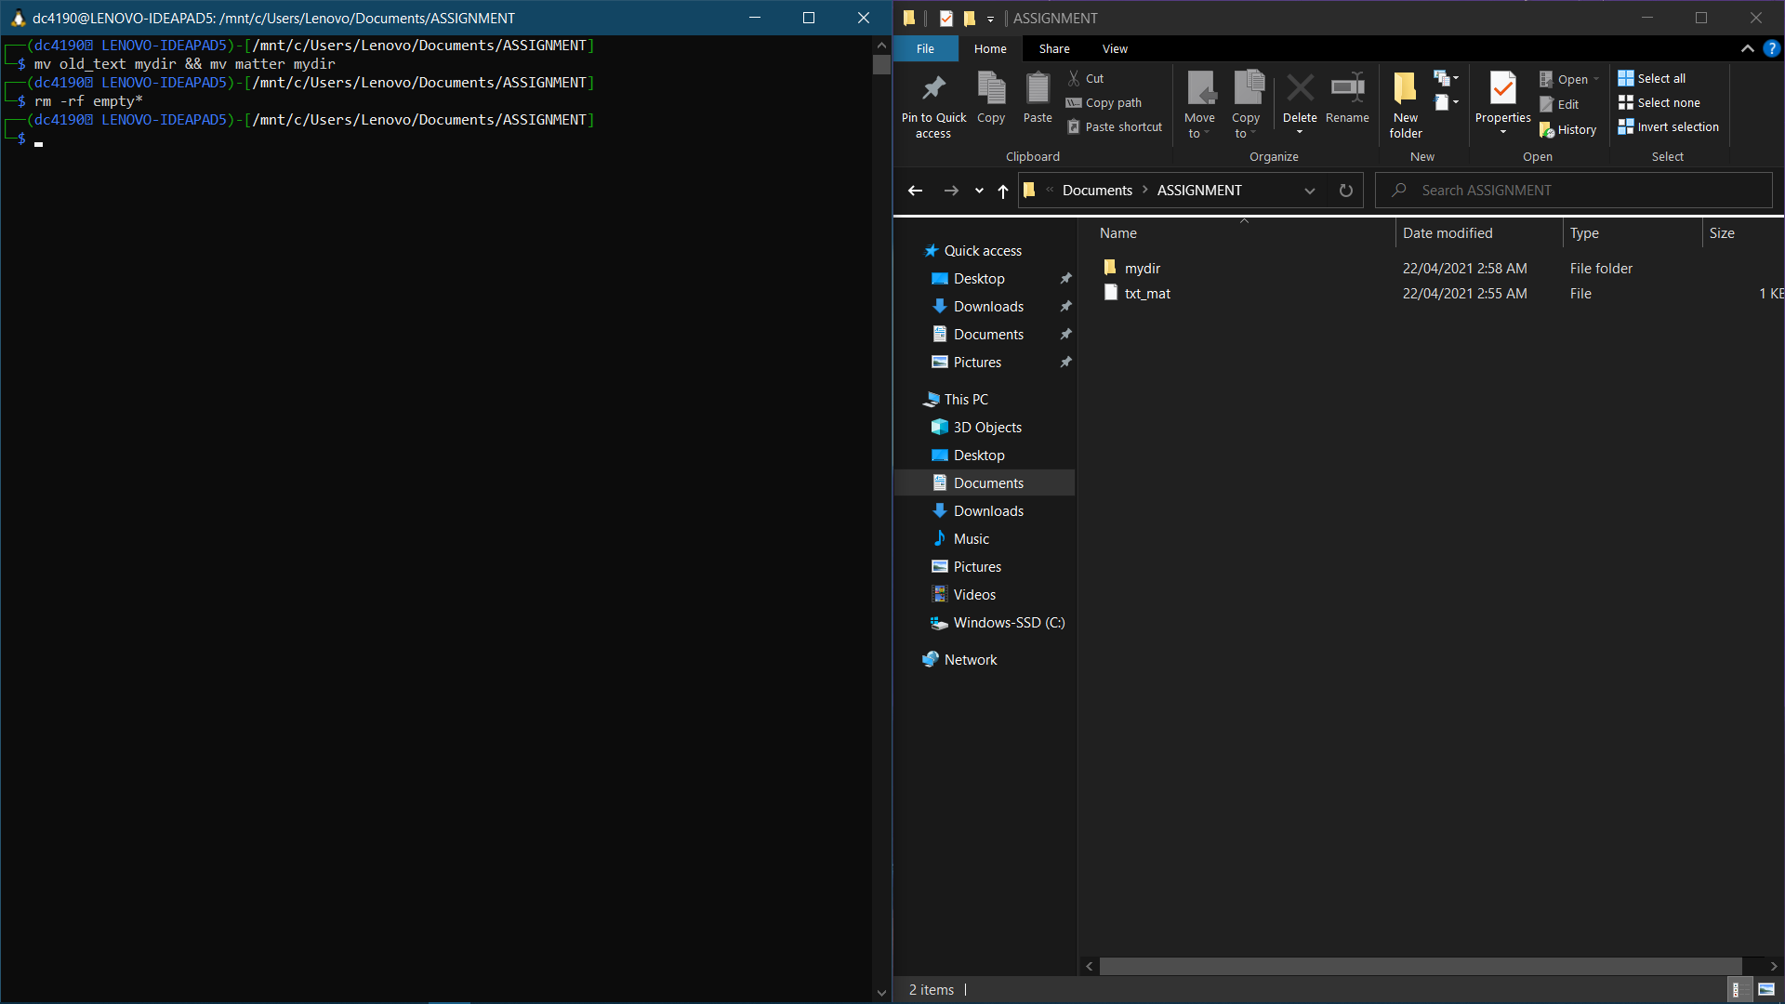

l) date +"%d/%m/%Y"

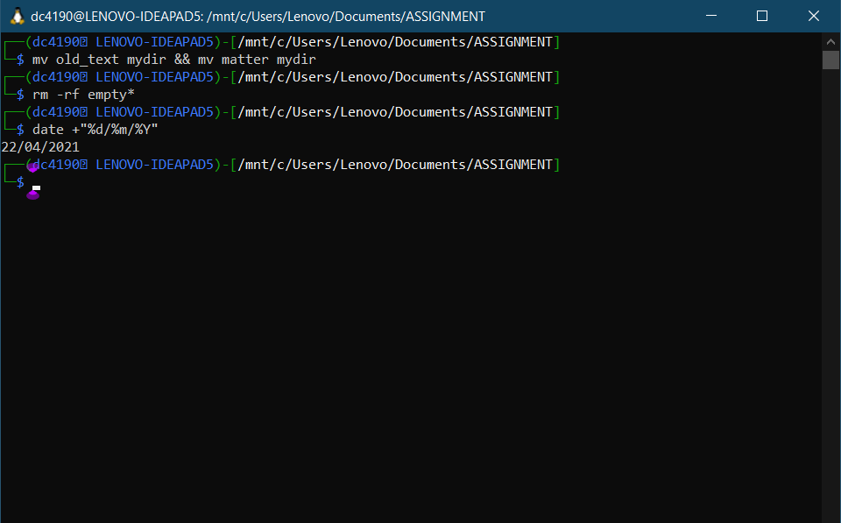

m) whoami

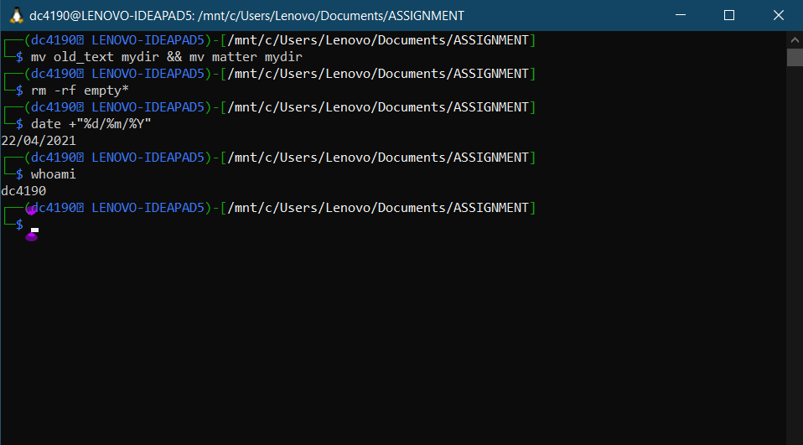

n) who -q

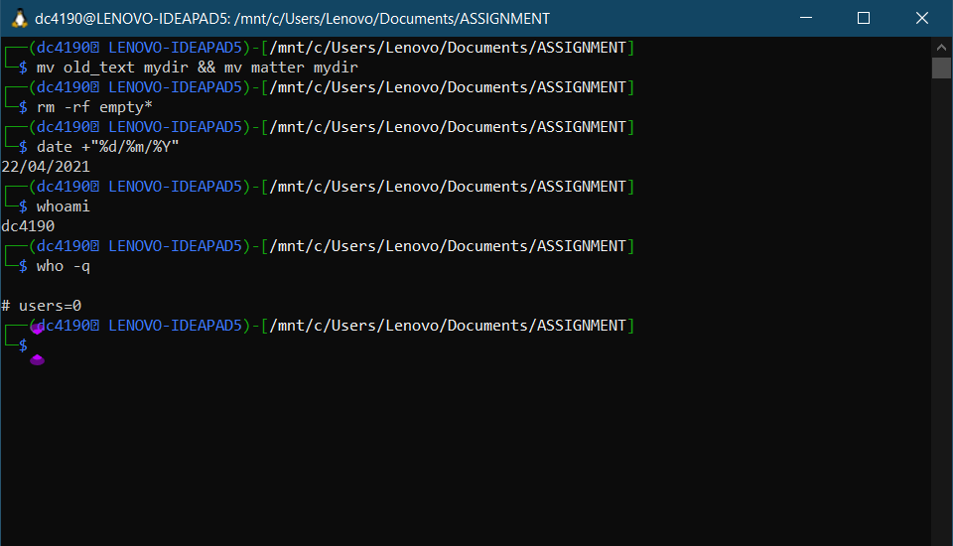

o) The rmdir xyz command will remove the directory xyz from the system. However, the directory must be empty before we can remove it, and we must have write permission in its parent directory. Hence, this command will fail to work if xyz directory is not empty.

p) Using cd without arguments will change the present working directory to home directory from any directory on the system.